VIKING DEFECT ANALYZES REPORT
Table of contents
1. Implement risk management. 1
2. Risk template 1
3. Top 10 risks in Viking project 2

- Implement risk management.
- Risk management process.
Risk management process is a process that was implemented during product development. Is the process of identifying and mitigating risks within a project. By controlling the level of project risk, we can:
- Create more accurate forecasts.
- Be more confident of completing deliverables on time.
- Increase your change of overall project success.
- Risk Management is comprised of the set of Process, Role and Document for managing risks within the project.
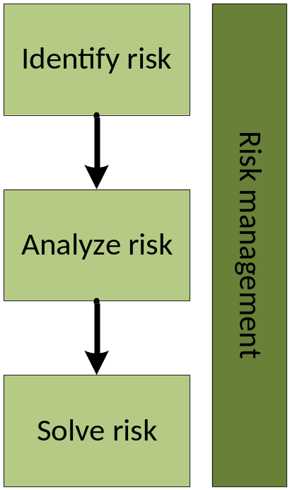
- Identify risk process.
In this step, project manager and team will identify risk may be happen in project. Project manager will make a plan, estimate and prepare resource for risk management.
Project manager will consider the sources may cause problems, find and list all things may be a risk in project (example: requirements, resource, budget…).
The stakeholders will help manager identify what is the real risk base on their expert. Manager will review, classify and list all possible risks in the project.
- Input is manager’s risks list and output is classified risks table.
- Include people: project manager, team members and stakeholders.
- Analyze risk.
In analyze step. Project management will organize meeting to analyze the risks have been confirmed in Identify risk process. The meetings will determine the impact of the risks, sources, the risk level and priority for each of them.
In this step, people will determine spent cost, time and resource if risk become a problem.
- Input of this process is classified table, output of step 1. Output of process is risk analysis report for each of risk (described in following parts).
- Include people: project manager, senior manager, team member.
- Solve risk process.
This step will describes solutions for the risks, impact assessment, cost, people, time required for action, process how to solve if risk occurs.
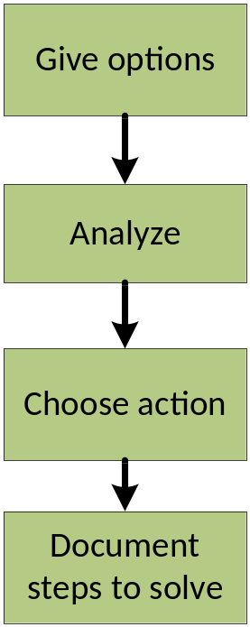
- Give options. Project manager will consult with the professionals related to this risk to give the options for this risk.
- Ignore the risk, as Team members believe it is not likely to occur within the Project Lifecycle
- Validate the risk and request further information that is needed to make a decision
- Decide on a suite of actions to avoid, transfer or mitigate the risk
- Analyze. Project manager will consult with the professionals related to this risk to analyze impact of risk solution if it occurs for each case. Include cost, resource, time and related module. What is happen when we ignore the risk, when avoid, transfer or mitigate the risk or when we face to the risk.
- Choose action. Base on above analysis, project manager will choose action for risk if it occurs.
- Document steps to solve. Project manager will estimates and document steps to solve risk, assign resource and budget for action. In addition, project manager.

- Risk Temple
ID: | Description of risk:
Probability | Note:
Priority
Timeframe:
Strategy:
Status:
Report:

- Top 10 risks in Viking Project.
Refer to the K15T1-Team11-Team Assignment10_Top_10_Risk.xlsx

